SILENT

AUCTION

ITEMS

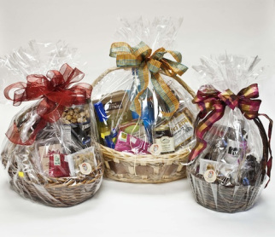

501 Margarita Party
Value $75.00
Donor(s): Herb & Judy Prouty

1.75 liter Jose Cuervo Especial Blue Agave Tequila, 1.75 liter Jose Cuervo classic margarita mix, salsa con queso, nacho chips, Klein Brother’s Salsa, “As Good As It Gets” DVD movie starring Jack Nicholson & Helen Hunt

502 Follow Your Heart
Value $100.00
Donor(s): Pam Livingston, The Proutys

Archetype cards by Carolyn Myss, $50 Movie Tavern gift card, Follow Your Heart ornament, marble swan, 4 crisp bamboo votive candles, 8 oz chocolate-scented natural candle, White Tea & Cactus Scentsy bar

503 Nailed It!
Value $75.00
Donor(s): Pat Schanz, The Proutys

$25 gift certificate to “Hair & Nails,” pumice stone, Heel-to-Toe moisturizer, 2 “Essie” nail colors, bottle of Courtney Benham Cabernet Sauvignon

504 Tea Break
Value $70.00
Donor(s): Carla Quinn

Variable temperature electric kettle with assorted teas and home-baked biscotti, 16 oz of Carla’s famous “C’zBz Honey”

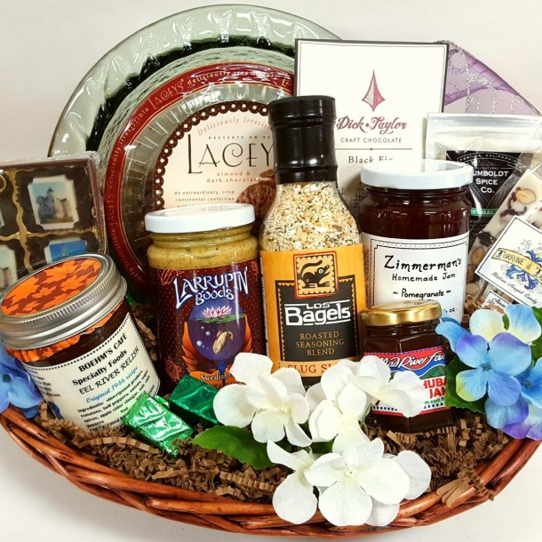
505 And All That Regalia
Value $50.00
Donor(s): Herb & Judy Prouty

1.75 liters of Chivas Regal Scotch whiskey

506 Tea Time
Value $75.00
Donor(s): The Calhouns

Cranberry Orange scones, Cup of Tea and Secrets of the Muse book by Ethan Walker III, Tea Forte Single steep pre-portioned loose leaf tea “Lotus” collection, wild blueberry scone mix, glass tea (loose) steep pot with insulation sleeve, Staffordshire tea cup & saucer, 4 teacup gourmet lollipops

507 Bird Watchers Special
Value $65.00
Donor(s): James Bolgiano

Vintage bird feeder, hummingbird feeder, finch feeder, premium bird seed, hummingbird food, illustrated bird ID book, 1992 Audubon magazine, hanging planter basket (matted)

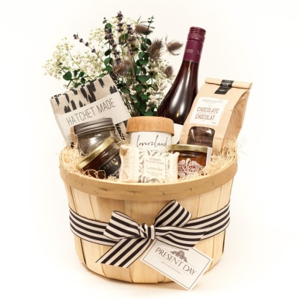
508 Martini Basket – Shaken Not Stirred
Value $75.00
Donor(s): Linda Eaddy

Tito’s Vodka, Dolin Vermouth, large olives, martini picks, napkins, 2 martini glasses, cocktail shaker

509 Viva La France
Value $75.00
Donor(s): Pamela Sybert

Pertois-Moriset Champagne, French Market coffee, French milled soap, Entre Nous book, butter cookies, hot pad, small dark chocolate bar

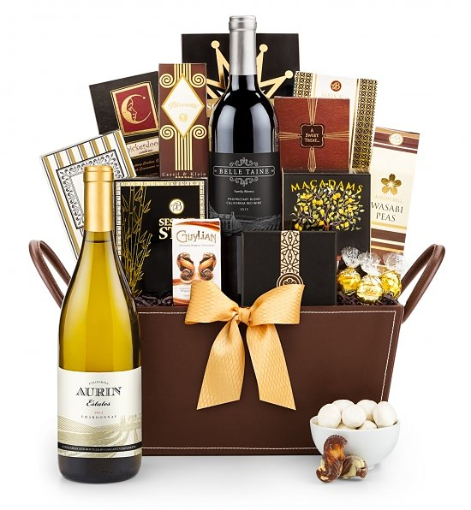

510 Chill Out And Relax
Value $50.00
Donor(s): Carla/Susan/Mabel

Bottle of O’Donnell’s Strawberry Cream wine, 8 oz stainless steel wine cup, note card set and pen, small “Choceur” rich dark chocolate bar, cherry blossom simple pleasure bath set with shower gel, body butter, bubble bath, bath salts & body spray

511 Honey, Take Care of That Brain
Value $40.00
Donor(s): Carla Quinn

Grain Drain by David Perlmutter MD, Honeymania shower gel and body butter, exclusive C’zBz honey, Full Moon Citrus Cider

512 Adorning Jewels
Value $45.00
Donor(s): David Raamiah

Elegant olive new jade and black agate necklace, expertly handcrafted by David Raamiah

513 E. T. Comes Home
Value $75.00
Donor(s): Ellen Davis

Vodka in collector Alien Head shaped bottle, collector Connecting Link magazines, collector 1959 book entitled Return of the Dove by Margaret Storm valued at $50, Cinemark $20 movie gift card

514 Ritzy Color, Crabby Shack
Value $45.00
Donor(s): Ellen Davis & The Proutys

Mer Soleil Silver Chardonnay, $25 gift card from Joe’s Crab Shack

515 Young Living Essential Oils
Value $75.00
Donor(s): Michele Collins

Essential Oils Reference Guide, oils – grapefruit/thieves/lemon, Zulu water bottle

516 Putting On The Ritzy Jewels
Value $75.00
Donor(s): David Raamiah

Blue and white marble lava with silver & pewter, expertly handcrafted by David Raamiah

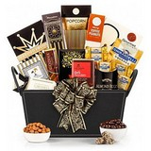

517 The Artist’s Way
Value $30.00
Donor(s): Pam Livingston, The Proutys

Primary color oil paints, brushes, 3 canvases, glass etching paint kit, glass container for etching, tie-dye art bag, $15 Starbucks gift card

518 A Tiny Slice of Heaven
Value $30.00
Donor(s): The Proutys

$20 Cinemark gift card, oven mitt, spatula, Betty Crocker Fudge Brownie mix

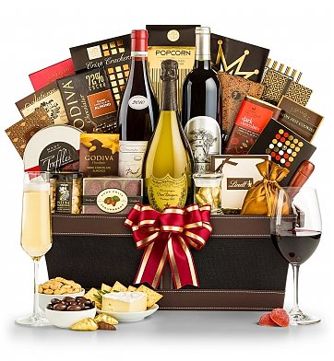519 Ritzy Rich Indulgence
Value $50.00
Donor(s): James Bolgiano, Carla, Mabel

Roscato Sweet Red wine, large Ghiradelli sea salt dark chocolate bar, $25 Cheesecake Factory gift card, book – Peace from Broken Pieces by Iyanla VanZant

520 Big Eatin’, BJ
Value $60.00
Donor(s): Herb & Judy Prouty

$50 gift certificate to BJ’s Restaurant & Brewhouse, oven mitt, whisk and Marie Callender’s Blueberry Muffin mix

521 I’m Beaming Now!
Value $25.00
Donor(s): Herb & Judy Prouty

750 mil bottle of Jim Beam bourbon whiskey

522 Desert Rose Pottery, Hand-Crafted by Angelicque Santana
Value $50.00
Donor(s): Angelicque, Mabel

Hand painted pitcher with four tall tea cups “Desert Rose,” $25 All Favorites variety gift card
523 BBQ Bonanza
Value $50.00
Donor(s): Pam Livingston, Calhouns

BBQ tongs, fork, turner, skewers, mitt, towel, apron, Kansas City BBQ Sauce, $25 Texas Roadhouse gift card

524 Essential Oil Bundle
Value $50.00
Donor(s): Friend of Nicole Caldwell

Four essential oil blends – “Balance & Center,” “Calm & Zen,” “Grounding” and “Sleepy Time.” See attached sheet for details.

525 Memory Lane
Value $60.00
Donor(s): Ellen Davis

12 x 12 album with album page kit with stickers, embellishments, Better Homes and Gardens Scrapbook Idea book with misc accessories, bottle of Ravens Wood Zinfandel wine

526 Kids Club
Value $35.00
Donor(s): Susan Keith, Pam Livingston

Tie-dye t-shirt (child’s medium), drawing pad and pencils, Pez dispenser, Lilo & Stitch DVD, Finding Nemo DVD

527 Movie And A Munch
Value $60.00
Donor(s): Herb & Judy Prouty

$50 gift certificate from Movie Tavern, oven mitt, plastic stir spoons, and Marie Callender’s Blueberry Muffin mix
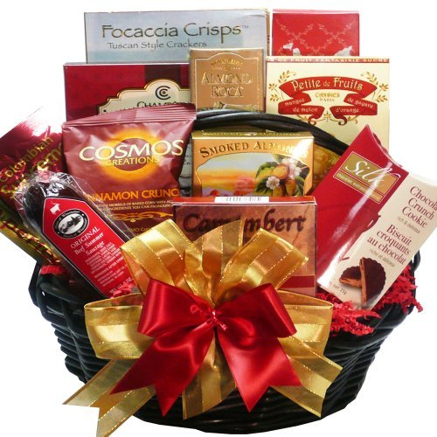

528 Herbs Galore
Value $75.00
Donor(s): Allen & Mabel Calhoun

Chef’s Guide to Herbs & Spices, Venus flytrap plant, garden gloves with claws, glass water bottle, non-GMO 2 Window-sill herb planter with trays in coconut pots (dill, thyme, sage, oregano, lavender), bite & sting ointment, 2 pear soaps, garden stickers, small hand shovel

529 Mary Kay Magic
Value $75.00
Donor(s): Pat Schanz

Mary Kay cosmetic and travel bag, including lipstick, cream foundation, mascara and eyeliner

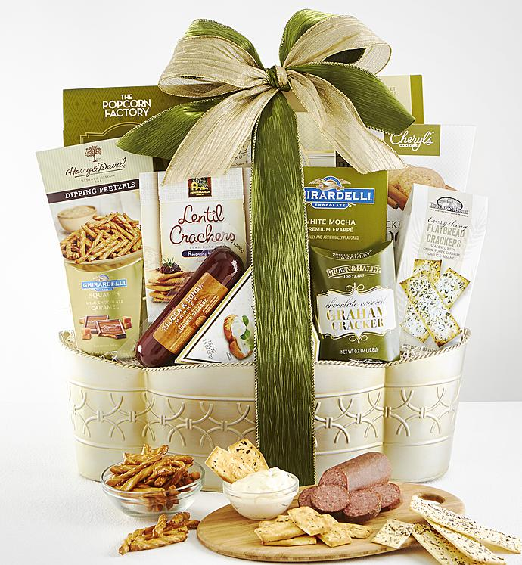
530 Cinco De Mayo Celebration
Value $60.00
Donor(s): Ellen Davis

Stella Rose wine, 3 gift cards to Chili’s ($10 each), tortilla chips, small taco shells, cookies, salsa, large taco shells

531 Reading and Relaxing
Value $95.00
Donor(s): Carla Quinn and Susan Keith

$25 Barnes & Noble gift card, Sterling Cabernet Sauvignon, book titled Ritz & Escoffier: The Hotelier, The Chef, and the Rise of the Leisure Class by Luke Barr, on-glass red wine infuser
532 Beauty Basket
Value $75.00
Donor(s): Pat Schanz

$40 gift card for Hair Illusions Salon, vent brush, Paul Mitchell Tea Tree shampoo and conditioner

