E
V
E
N
T
S

Ballroom Dance Lessons - $45.00
Date: August 11, 2018 – 6:00 PM
Twelve Tickets Available
Donors: Ryan & Belinda Toornburg

Ryan and Belinda will provide snacks, music and the instruction for a fun night of social dancing. If you can walk a line or make a box, you can dance! You will learn the basic dance frame and pressure points for the proper way to lead and follow in Ballroom. Styles such as waltz, foxtrot and cha cha will be taught in easy to learn basic moves for both the ladies and gentlemen. Ryan will be assisting as a lead for any ladies taking the class solo. No prior dance experience needed.

Barbeque & Poker Party - $35.00
Date: October 6, 2018 – 6:00 PM
Six Tickets Available
Donors: Pat & Fritz Schanz

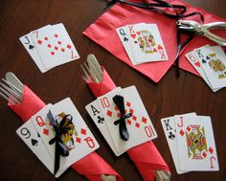

Ante up for a fun evening at the Schanz home for a real live Texas event featuring Texas’ favorite brisket, beans and all the fixins’ followed by the game of the state - Texas Hold ‘Em.

Murder at the Grand Gatsby - $40.00
Date: January 26, 2019 – 6:00 PM
Fifteen Tickets Available
Donors: Allen & Mabel Calhoun

A roaring 20s murder mystery game set at the height of prohibition. Join us if you are up for loads of blackmail, deceit, intertwining relationships and murder – all packaged in a fun flapper and gangster themed murder mystery dinner party. An Italian dinner will be served. Event held at the church.

Suicide Prevention Class - $15.00
Date: July 22, 2018 – 1:00 PM
Twenty Tickets Available
Donor: Dr. Nicole Caldwell

Join Dr. Nicole Caldwell, at the church, as she leads a suicide prevention training class using the QPR - Question, Persuade, Refer techniques. Learn to recognize the signs of a person at risk, know what to say and do and where to get help. These tools could help you save the life of a family member, friend, co-worker or complete stranger.

Led Zeppelin Night - $20.00
Date: February 15, 2019 – 6:00 PM
Fifteen Tickets Available
Donor: Pam Livingston

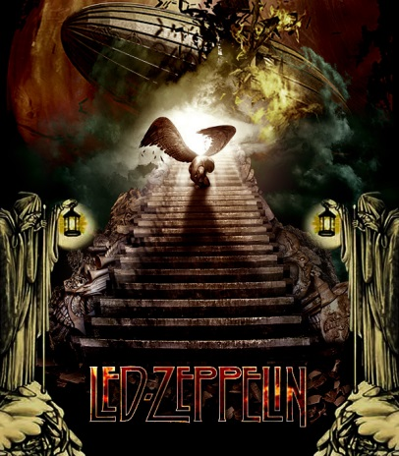
How much do you know about the band Led Zeppelin? Join Pam Livingston at the church where we will enjoy an evening featuring a few videos from the 70s and end with some videos and details about the band members over the years. There will be some trivia questions and a prize or two. Pizza, popcorn and beer will be served along with a bit of wine.

Family Memento Workshop - $20.00
Date: September 22, 2018 – 6:00 PM
Ten Tickets Available
Donor: Ellen Davis

Ellen will share various unique and creative ways that she passes down family stories and traditions which keep alive treasured family memories. Each participant will be asked to bring a family recipe with a photograph of a person or time when that recipe was used. Create a memento that your family will appreciate for years to come.
Women of the World Song/Parody Show - $25.00
Date: January 12, 2019 – 6:00 PM
Forty Tickets Available
Donors: Kay Lamb & Pamela Sybert

Kay Lamb and Pamela Sybert will be presenting a program of song and hilarity featuring women throughout history. Kay will be singing songs parodied by Donna Trammell, Denton’s Premier Parodist. Pamela will be introducing each song with information about the woman presented. Wine and appetizers will be served.

Crochet For A Cause - $20.00
Date: September 15, 2018 – NOON
Ten Tickets Available
Donor: Belinda Toornburg

Belinda will provide crochet hooks, various yarns and one piece of fleece material for participants to create a blanket. She will teach you how to crochet so NO prior experience is necessary. She will get each person started on a blanket that will be finished by them at home. Upon completion, they will be returned to Belinda who will donate them to charity. Last year she made 35 blankets for the kids at the homeless shelter in McKinney. Lunch will be served. Event will be held at the church.
Fly Fishing Instruction & Beer
Tasting - $25.00
Date: To Be Determined
Four Tickets Available
Donor: Fritz Schanz

Learn to cast like the people in the movies and have some beer. Spend an afternoon with Fritz Schanz, certified fly fishing instructor and award-winning craft beer brewer.

Fitting in at the Ritz: The Power of Rapport - $25.00
Date: June 16, 2018 – 6:00 PM
Thirty Tickets Available
Donor: Lisa Allen

Join us for a great evening of discovering how to fit into any group! Rapport is the ability to relate to others in a way that creates trust and understanding. It creates a connection that allows everyone to express their point of view, explore differences, and remain on friendly terms. Event will include alcoholic beverages and heavy hors d’oeuvres, an experiential workshop to explore rapport and concludes with a screening of the 1957 American courtroom drama film classic ”12 Angry Men.”
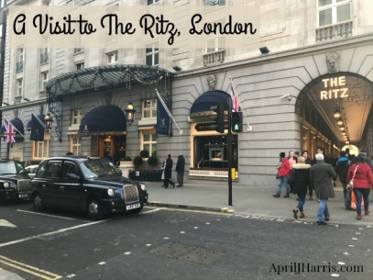

Silk Scarf Dyeing & Lunch - $25.00
Date: July 7, 2018 – 10:00 AM
Six Tickets Available
Donor: Pam Livingston

Join the group, at the church, to enjoy a morning of dyeing silk scarves (2 scarves per person), followed by a salad lunch while scarves dry. We’ll ‘strut our stuff’ as we model our new creations for one another after lunch.

Movie Showing & Discussion Premonition - $20.00
Date: June 22, 2018 – 6:00 PM
Twenty Tickets Available
Donor: Ellen Davis

Can you Change Your Future? Ellen will show the movie “Premonition” starring Sandra Bullock which brings up the question of whether we can see into the future and if we can change it. A drawing will be held and snacks will be served along with a sharing time about our own experiences after the movie. Event will be held at the church.

Putting on the Ritz in Paris - $45.00
Date: July 14, 2018 – 6:00 PM
Six Tickets Available
Donors: Allen and Mabel Calhoun

The Calhouns will help you explore Paris with your palates. Join us for a dinner party featuring French cuisine and wine. Bon Appetit!

Ellen’s Spiritual Journey – Hopi Mesas to Peru - $20.00
Date: September 28, 2018 – 6:00 PM
Twenty Tickets Available
Donor: Ellen Davis

In the 1980s Ellen Davis went to the Hopi Mesas with a small invited group of people and was led on a spiritual journey with the son of the Hopi Chief. This led to a follow-up trip to Peru for almost 3 weeks on a shamanic journey where she saw and experienced fascinating spiritual realities. Ellen will share this experience in a slide presentation. Snacks will be served. Event held at the church.
Fishing Adventure with Fritz - $35.00
Dates: TBD
Six Tickets Available
Donor: Fritz Schanz

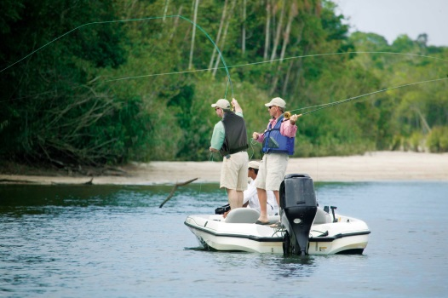

Fritz Schanz is offering two separate fishing adventure sessions. He can take 3 people per session. Spend a morning on Lake Ray Roberts fishing from Fritz’s professional grade Sea Hunt boat. No extra charge for actually bringing in a fish! Each ticket buys you one seat on one adventure. Fritz will provide the fishing equipment.

Oktoberfest – Bierocks and Beer -$25.00
Date: October 12, 2018 – 6:00 PM
Ten Tickets Available
Donor: Pam Livingston

Pam Livingston grew up in a German community that regularly served bierocks on her school lunch menu. Enjoy an evening tasting these delectable delights that feature ground meat, cabbage and seasoned sauerkraut nestled inside a warm bun. We will be tasting German beers and enjoying some polka music to round out the festivities. Brush up on your German trivia, especially the food and beverage details. There may be some questions to answer and the winner might walk away with a decorated beer mug!
Movie & BBQ - $20.00
Date: August 4, 2018 – 6:00 PM
Four Tickets Available
Donors: Herb and Judy Prouty

Herb and Judy Prouty will be hosting a movie night at the church. The movie “The Post” will be shown. The film is based on a true story and Meryl Streep and Tom Hanks are the stars. Determined to uphold the nation’s civil liberties, Katharine Graham (Streep), publisher of The Washington Post, and hard-nosed editor Ben Bradlee (Hanks) join forces to expose a decades-long cover-up. But the two must risk their careers – and their freedom – to bring truth to light in this powerful film with a celebrated cast. A BBQ supper will be served.

Nature Photography & Lunch - $20.00
Date: To Be Determined – Spring 2019
Seven Tickets Available
Donor: John Naab

John will organize a nature photography outing in which the participants will visit several sites suitable for capturing the beautiful outdoors. The group will stop for a dutch treat lunch. Spend time with fellow photographers and share tips for snapping the perfect photos.
Aging and Spirituality - $25.00
Date: March 9, 2019 – 10:00 AM
Ten Tickets Available
Donor: Pamela Sybert

Do we get more spiritual as we age? Do we get less spiritual as we age? Do we stay the same? Pamela Sybert, M.S. in Applied Gerontology, will explore this topic with participants. In this interactive workshop, we will look at some of the fascinating research that has been conducted, and you will have the opportunity to “map” your spiritual path. A healthy lunch will be served.

Christmas At The Ritz - $45.00
Date: December 15, 2018– 6:00 PM
Ten Tickets Available
Donors: Allen and Mabel Calhoun

Join us at the Calhoun home for an elegant surf and turf dinner in an ambient environment decorated for the holidays. We will enjoy sounds of the season and may even have a sing-along of your favorite carols. An entertaining evening to get you into the Christmas spirit!

DiMassi’s Mediterranean Buffet- $30.00
Date: October 20, 2018 – 6:30 PM
Eight Tickets Available
Donor: John Naab

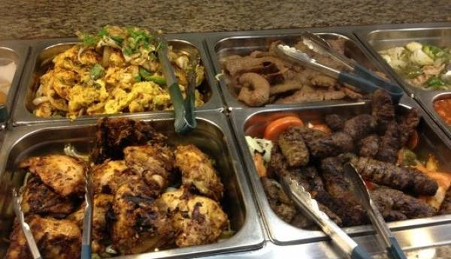

John will host a group of 8 at this fabulous Lebanese-Mediterranean buffet located in Plano. The environment is casual and the food is of highest quality. You will want to come hungry!

Believing in the Dream!
PSYCH-K Session - $35.00
Date: June 10, 2018 – Specific Session Times
Nine Tickets Available
Donors: Judy Prouty, Lisa Allen & John Naab

Are you ready to shift your consciousness? Have you been frustrated by affirmations that seem reluctant to manifest in your life? Do you feel the global changes that are occurring and want to be a part of that wonderful shift? PSYCH-K can help you quickly and painlessly change the subconscious beliefs that are limiting the full expression of your potential in life. In a one-hour session, you will work with a trained PSYCH-K practitioner to identify a goal and then quickly and easily eliminate the limiting beliefs and habits of thinking that are blocking your attainment of that goal. Don’t just Put on the Ritz; BE THE RITZ!!!
Judy, John and Lisa are each offering three one-hour sessions. Sign up for the specific facilitator and time of your choice.
Tiptoe Through the Tulips - $25.00
Date: March 16, 2019 – 10:00 AM
Rain Date: March 23, 2019 – 10:00 AM
Eight Tickets Available
Donor: Susan Keith

Susan will take a group of 8 to Texas Tulips, a tulip farm in Pilot Point. Each participant will pick 3 tulips (or more if you choose to pay for more) and use these as part of a spring bouquet. We recommend that you bring gardening gloves and small clippers. The group will then go to the church for a light lunch followed by a flower arranging class. Susan will provide instruction, vases and additional flowers, greenery and tools to help you create your arrangement.

In-Sync Exotics Tour & Lunch - $20.00
Date: TBD
Sixteen Tickets Available
Donor: Carla Quinn

Carla will arrange a tour of In-Sync Exotics Big Cat Sanctuary located near Wylie, Texas with a tour guide. Each attendee will be responsible for their own donation to the Sanctuary ($12 per person minimum). Carla will provide a picnic lunch. Cats include several white tigers, tigers, lions, bobcats and others.

Ladies Who Lunch at the Ritz - $25.00
Date: March 30, 2019 – NOON
Eight Tickets Available
Donor: Mabel Calhoun, Shari Turner, Kay Lamb & Angelicque Santana

Join us at the Calhoun home for a lunch at the Ritz experience. Lunch will feature your favorite Spring delicacies. Shari will lead the Bunco games (prizes will be awarded). Angelicque will offer unique psychic readings to the guests. Bring your floppy hats and fake pearls and enjoy a day of fun and laughter – with a little booze to soothe away your cares.

Drone Flying Experience - $35.00
Date: To Be Coordinated with Ryan & Bidders
Three Tickets Available
Donor: Ryan Toornburg

Have you ever wanted to try your hand at flying a drone? Ryan is offering 3 separate one-on-one sessions. He will provide instruction for flying the DJI Phantom 3 drone. He will coordinate with each bidder on a time and place to fly. You will be given a copy of your footage or images of your flight.

Sacheting Through Lavender - $25.00
Date: May 19, 2018 – 8:45 AM
Eight Tickets Available
Donor: Lisa Allen and Judy Prouty

What a lovely way to spend a late Spring day! We’ll meet at the church at 8:45 AM and travel to Lavender Ridge Farms in Gainesville, TX. We’ll spend some time there, enjoying the beauty of the place and eat lunch in their quaint café featuring foods made with lavender. We will return to the church for a workshop to learn about using lavender.

Escape Room Adventure - $35.00
Date: TBD
Seven Tickets Available
Donor: Kim Stewart

Kim Stewart is organizing an outing at North Texas Escape Rooms in McKinney. Join fellow bidders as you solve a series of puzzles and riddles using clues, hints and strategy to escape the room you are locked in as quickly as possible. She will also treat participants to lunch at TGI Friday’s.

Releasing Journaling Meditation - $20.00
Date: TBD
Six Tickets Available
Donors: Kim Stewart

Kim Stewart will lead a small group in a Releasing Meditation exercise where participants set intentions, journal and meditate together.

Please remember to pick up your tickets for each event purchased from the ladies at the Check-Out Table.

